Creative thinking
by Drew Boyd

Introduction
Do you want to be happier? Do you want to be more successful? And do you want to be more confident in the decisions you make? One way to achieve all three is to be more creative. this course is for everyone.

The world of creativity
- Why be creative?
- What is creativity?

Creative thought (3 criteria)
  - new: never had it before
  - useful: can be put into practice for somebody’s benefit innovation
  - surprising:

how does the brain produce these ideas Geneplore: generation & exploration
it generates a concept and then explores the value of that concept.
The creative concept gets in your head when you force two previously unrelated themes to suddenly collide or come together.
The brain starts with an undeveloped form created by this collision, then searches your memory for some reason why that form would be useful.

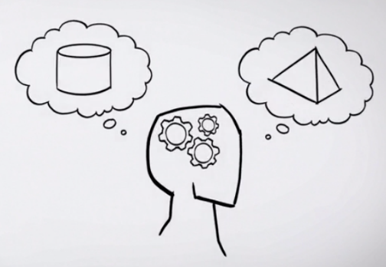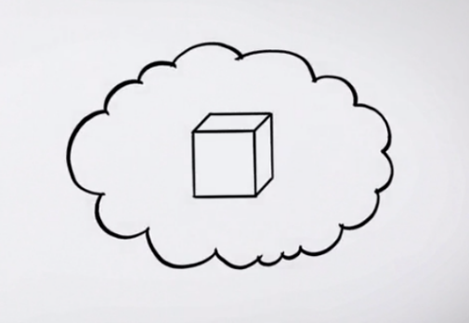

- Understanding ways to learn creativity
Voice of the product

- Understanding the barriers to creativity
Surprisingly, constraints are not a barrier to creativity. In fact, constraints are a necessary condition for creativity to occur. Your brain works harder and smarter when given tight boundaries. The more constrained you are, the more creative you'll be.

what is it that seems to limit our creativity? the answer is a condition known as fixedness.
Fixedness is a cognitive bias that limits our ability to see the world around us differently than what we're used to. There are at least three types.
  - Functional fixedness: makes it hard for you to consider an object doing a job other than what you know it to do.
  - Structural fixedness: makes it really hard to imagine objects having a different structure than what we're used to.
  - Relational fixedness: makes it very hard to imagine two objects having a relationship that wasn't there before.

Individual creativity
- How patterns channel our creativity
Innovators have used patterns into their inventions, usually without realizing. Those patterns are now embedded into the products and services you see around you as the DNA of a product or service.

Systematic Inventive Thinking (SIT)
With SIT, innovation follows a set of patterns that can be reapplied to any product, service, or process. What these patterns do is they channel your ideation process.

The majority of innovative products and services can be explained by just five patterns.
  - Subtraction: the elimination of a core component, something that seemed essential at first.
  - Task unification: a component of a product has been assigned an additional job, one that it wasn't designed to do
  - Multiplication: a component but changed the component in some counterintuitive way.
  - Division: divide a component along some physical or functional line, and then rearrange it back into the product.
  - Attribute dependency: a product has a correlation between two attributes, one of the product and its environment. As one thing changes, another thing changes.
These five patterns are a crucial foundation to being creative.

- Understanding function follow form
Most people think the way you create an idea is to start with a well-formed problem and then brainstorm a solution to it. Well, what if you turned that around 180 degrees? It sounds counterintuitive, but you really can innovate by starting with the solution and then work backwards to the problem.
In the systematic inventive thinking method, we call this direction of thinking the function follows form principle.

Function follows form principle
innovate by starting with a solution and then work backwards to the problem.
  - start with an existing situation. That situation can be a product, it can be a service, or perhaps a process. You take that item and you make a list of its components and its attributes.
  - apply one of the five thinking tools. They're called subtraction, division, multiplication, task unification, and attribute dependency. Now when you apply one of the five tools to the existing situation, you artificially change it. It morphs into something that at first might seem really weird or even absurd. That's perfectly normal. In fact, as you get more comfortable with this method, you'll come to expect it. Now we consider this strange thing a virtual product. It doesn't really exist except in one place, right up here in your mind. Now take your time when applying one of the five thinking tools. You have to mentally define and visualize this virtual product. I like to close my eyes at this step and mentally see an image of the item once it's been manipulated. Now as you practice the method more, this will get a lot easier.
  - ask two questions (and you do it in this specific order)
    - should we do it?
    - can we do it?
Does the concept help people in any way and, if so, is it feasible to make? If it doesn't meet these simple criteria, don't waste any more time on it.
  - adaptations step (If you pass through both questions) modify the concept to make it stronger.
You may have to iterate through these steps several times before you end up with what I would consider an idea.

- Subtraction
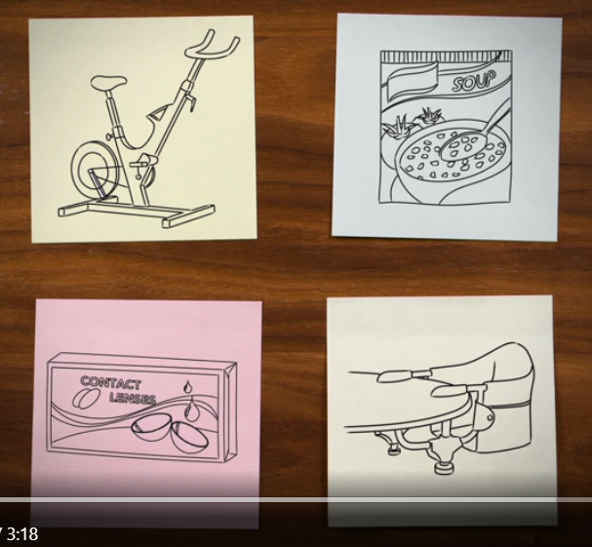
an exercise bicycles has had the rear wheel removed
a package of powdered soup has had the water removed
a contact lenses had the frames removed
a child's highchair, the kind that slips over the edge of the table has had the legs removed.

define: the elimination of an essential component of a product. To use the technique, follow the steps of the function follows form principle.
  - list all the internal components.
  - removing a component.
  - ask yourself two questions
the subtraction technique allows you to replace the function of the missing component. it breaks fixedness and forces you to mentally imagine all the remaining components delivering some new value.

- Division
Division is a powerful technique because it forces you to break fixedness, especially structural fixedness. Division forces you to create configurations by rearranging components in ways you were not likely to have done on your own.

separate the product or its components and then rearranging them back into the product.
  - listing the product’s internal components.
  - divide the product or one of the components (3 types)
    - divide functionally, where you rearrange along some functional role.
For example, a water sport company took the controls of the speedboat and then functionally divided them off and placed them into the handle of the water ski tow rope, now the water skier controls the movements of the boat without having a separate driver. Next is
    - divide physically, where you are cutting the product or component along any physical line.
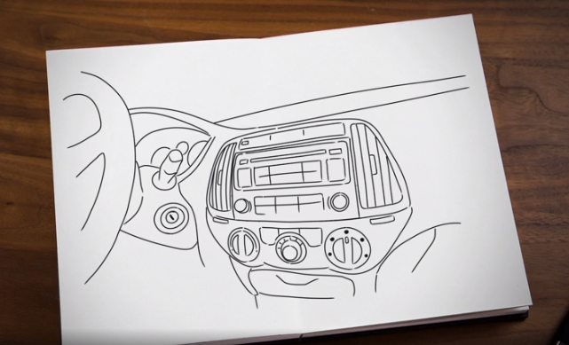
Take a look at this car radio. In this example, the faceplate has been physically cut away from the main radio. When you leave your car, you grab the faceplate by pulling it away from the main radio and taking it with you. That makes the main radio completely worthless so thieves won't break into your car to steal it.
    - divide through preserving. That means you divide the product into smaller versions of itself. Each smaller unit preserves the characteristics of the whole.
A real simple example of this is what you see here. Cupcakes are essentially smaller versions of a normal-sized cake. So, once you've rearranged the components, your work is not done, you still need to ask yourself two important questions in the right order. Should we do it, and can we do it? Finally, you modify and adapt the concept to improve it.
The division technique cuts your biggest challenges down to size so you can see new innovative opportunities.

- Multiplication
A common problem in photography is the occurrence of red eye. Red eye happens when the flash of a camera goes into the eyeball. It hits the back of your eye, which has a lot of tiny blood vessels. The light picks up the red color from the blood in those vessels and it bounces straight back into your camera lens. Your friends get that eerie red eye look. But today's cameras have a clever and simple way to defeat red eye. They have a dual flash. The first flash causes the person's pupil to constrict enough so that very little light will get in. At that exact moment, the second flash goes off and lights up the subject matter. Voila, no red eye. This innovation is a classic example of the multiplication technique.

define: copy an element already existing in a product but change it in some counterintuitive way.
  - listing the components of the product, process, or service.
  - Make a copy of one of the components and change it
  - You pick one of those components and you make a copy of it. You keep the original component as is, but the copied component is changed. That's what creates the virtual product.
  - look at the potential benefits: and you modify or adapt the concept to improve it to yield an innovative idea.
So how do you change the multiplied component? Let's use a refrigerator to demonstrate this handy tool. First, create a table like the one you see here. You list the components down the left hand column. Then, for each component, you identify its attributes. Attributes are things like its weight, its shape, its height, or its color. You list the attributes for each component. Now, here in the far right column, you start to visualize each virtual product for each multiplied component and each of its attributes. A simple table like this can help you keep organized using this very powerful technique.
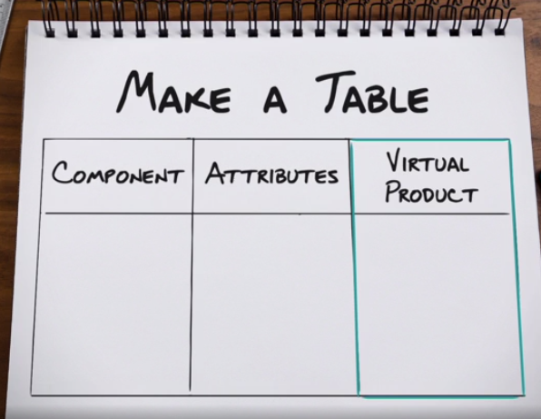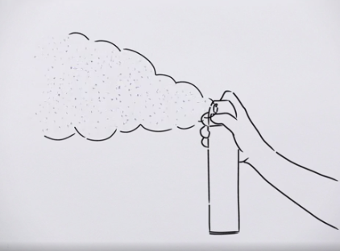

Now here's an example of multiplication. The consumer products company, Proctor and Gamble, used the multiplication technique to create the Febreze Noticeable air freshener. It's called Noticeable because it has a very clever way to keep you smelling the scent. After a period of time, your nose becomes too accustomed to a smell, and the brain shuts it out, but this little product gets around that. It has not one, but two different scents. The first scent pulses out into the room, but then stops right about the time your nose stops recognizing it. Just then the second scent starts pulsing out into the room. Your nose picks up where the other one left off. Pretty clever.
Multiplication accounts for many new products and services and it's straightforward to use. You want to make this powerful technique part of your innovation arsenal.

- Task unification
The famous inventor Thomas Edison lived in a beautiful home, but something was unusual about the gate that led into his house. His visitors had to push the gate very hard to open it, and then again, very hard to close it. It seemed odd that such a successful inventor like Thomas Edison wouldn't fix his gate. Well rumor has it that Thomas had attached a pump to his gate so that every time someone opened or closed it, they were pumping fresh water into the plumbing system of his house. This is a great example of the innovation technique called task unification. The gate has its primary job of letting visitors through, but it also has the additional job of pumping water. But that's not all of the story, the guests coming to visit Thomas are also a resource. They have their primary job of being friends of Thomas, but now they have the additional job of activating the gate to open and close it.

define: assign additional tasks to an existing resource.

  - listing the product's internal components and external components
  - select a component and assign it an additional task.
  - look for potential benefits and you modify (or adapt the concept to improve it.) three general ways
    - an internal component takes the job of another internal component.
Think of it as that component is stealing the function of the other component. Here's an example. What you see here looks like an ordinary coffee maker. In fact, this product has a clever little innovation inside. The coffee maker's filter has the additional job of measuring just the right amount of coffee to use given how much water was put in. It gives you the perfect brew every time.
    - an internal component takes the job of an external component.
Nissan, the Japanese auto maker, has a nifty idea to make it easier to fill your tires with air. The car's horn will beep to let you know when you've reached the right tire pressure. It's called the easy fill tire alert. In this example, the car horn steals the job of the tire pressure gauge.
    - an external component takes the job of an internal component.
Imagine billboards in a subway station that show grocery products on the shelves just the way you would see it in a store. Commuters use their smartphones to scan the products they need, and that shopping list is sent to the grocery store so the commuter can stop by on the way home to pick up the groceries. In this example, the billboards are assigned the additional task of becoming the point of sale. Very convenient, and it saves time. And that's how task unification can lead you to some pretty clever ideas.

- Attribute dependency
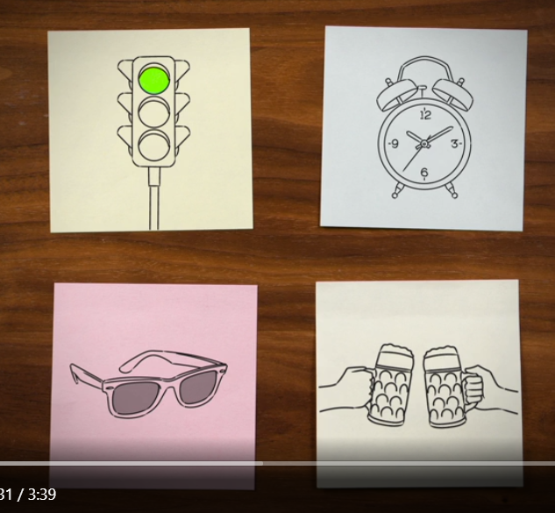
In each case, one item is changing in response to something else.
In the case of the traffic light, it turns green in response to the presence of a car at the intersection.
The loudness of the crescendo alarm clock changes in response to time.
The darkness of the lens changes in response to the brightness of the external light.
And happy hour, (laughs) well, the price you pay for drinks at a bar, changes in response to the time of day.

define: one thing changes as another thing changes
, and that is the hallmark of the attribute dependency technique. To use attribute dependency, you make two lists.
  - list attributes of the surrounding environment and people related to the topic (you're working on.) Now these could be physical attributes like width or length or height. They might also be characteristics of people like gender, age, and personal preferences. I suggest you always include on your list the attribute of time. That could be time of day, elapsed time, and so on, whatever best relates to your topic. Now be sure to number these attributes one, two, three, and so on.
  - list attributes of the product or service.
components are physical or tangible / attribute are a characteristic
For example, the screen of a TV is a component, while the size of the screen would be an attribute. Now be sure to list these out with letters, A, B, C, and so on. Now you're ready to apply attribute dependency. Randomly select one attribute from each list. For example, attribute five and attribute C. Now here's the critical part. Create a simple phrase that sounds like this.
As attribute ______ changes, so does attribute _______. That becomes your virtual product.
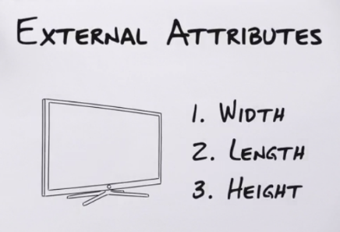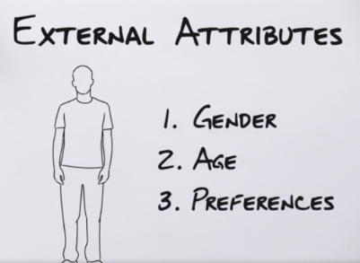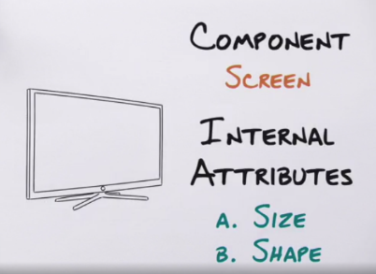
  - identify potential benefits and target markets.
  - modify and adapt the concept to improve it.
Look at the previous examples like the crescendo alarm clock. Our virtual product would have been as elapsed time increases, the loudness of the alarm increases. These attributes would have come from the two lists we would have created. To demonstrate attribute dependency, I've provided an Exercise File. Attribute dependency is powerful, so be sure to use it the right way, to create amazing creative concepts.

Group Creativity
- How to create a creativity dream team
diversity
  - functional: team member from different parts of the company
  - gender: research suggests men tend to create more aggressive ideas while women are more pragmatic. Working together averages out these tendencies to produce novel and practical solutions.
  - cultural: The best teams have members with different ethnic backgrounds, they broaden the team's perspective on how best to commercialize new inventions on a global scale.
Tips
  - Be sure to keep the group size at 12 or less. Any larger than that becomes hard to facilitate.
  - Be sure participants are fully committed to participation. Avoid letting people drop in and out as it suits their schedule. Otherwise, it interrupts the flow of the workshop.
  - Be sure participants have the right level of knowledge. They'll have trouble contributing if they know nothing about the subject matter.
  - Make sure you reward the participants for being part of your session. You do that by practicing the golden rule of creativity, give back your time and expertise to those who gave it to you. The most creative people practice the principle or reciprocity by helping others and asking their help when needed.

- How to facilitate group creativity
steps to running a great workshop.
  - decide on a workshop location.
  - (When you begin your workshop, start by) identify constraints. Constraints might include budget issues, timing, or legal and regulatory boundaries. without constraints, the ideation will lack focus. You're likely to generate ideas that are too wild to be viable. Next, make sure you and the participants define the closed world around the problem. Where you define this imaginary space around the problem will have a big impact on how you apply each technique.
  - decide which of the five techniques to apply.
  - create a list of the components and. Make sure you number the list. That helps keep the workshop more organized as you work through the lists.
  - work in smaller groups when applying the techniques (teams of two, or perhaps three people, not as one big large group.) Working in pairs is also more efficient. As you apply a technique, assign each pair a different component from the list. That forces them to really focus and it increases their chance of coming up with a creative idea. Be sure to set a specific time limit, say, three minutes. This further constrains their brain to think inside the box.
  - Prevent bias with ideas. When ideas are generated try not to identify them with a specific person. Otherwise people may bias the idea depending on who generated it. A simple way to do this is to have people write down their ideas. When giving credit for the source of an idea, make sure it's from the pair of colleagues, not just one person. You have to find ways to strip ideas of their identity. This will make sure ideas don't get thrown out prematurely. A typical workshop can be anywhere from an hour in length to several days. Hey, innovating is hard work, so be sure to manage the group's energy level. Take a lot of break during the workshop and mix up the activities to keep people engaged. Using good facilitation techniques will make sure you get the most out of your creativity workshop.

- How to select the best ideas
ways to evaluate ideas.
  - decide what qualifies as a great idea. In other words, what criteria should you use to evaluate ideas? Now it's important you do this first, before even looking at the ideas generated, otherwise you run the risk of the ideas creating the criteria for you. Say you really like an idea, but it doesn't meet all your criteria, so you make up new criteria to fit the idea. That's wrong, and it will lead to errors in judgment. So what criteria do you select? Well, that's completely up to you, but don't have too many, four or five at most, and actually fewer is better. Let the most important criteria do the job for you. From my experience, most criteria fit into two types.
    - How well does the idea fit with your company and its culture, and
    - how much of an impact does the idea have on your business?
  - put all your ideas in a standard format. That'll make it a lot easier to evaluate them. I like to use a template like this, name of idea, description of idea, benefits, the target audience, and challenges. Every idea should have its own name, not just a number. Give it a name that will help people see what the idea is about. Use literal names, not vague or confusing ones.
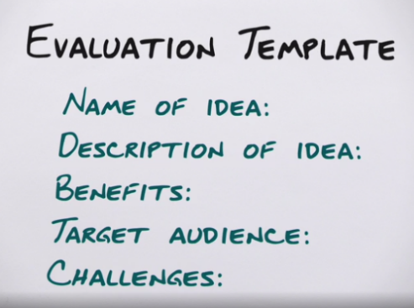
  - evaluate your list of ideas.
    - Individuals review lists of ideas. First, let each member of the group read the entire list of ideas with all the benefits and challenges. They do this on their own.
    - Individuals vote for their favorite ideas. Then, using the criteria you decided on earlier, each participant is allowed to put check marks beside the five or six of their favorite ideas meeting the criteria.
    - Votes are tallied. The votes from each participant are tallied to determine the top ideas. Voting individually and anonymously has a lot of benefits. Each individual has their own biases of what makes a great idea, and they vote accordingly. But voting as a group tends to neutralize those individual biases. From my long experience, the group vote always tells you which ideas the company will prefer. True innovators generate great ideas, but they also use the wisdom of others to help evaluate them.

Conclusion
If you visit my Pinterest site, for example, you'll find a board for each of the five techniques with examples of products that demonstrate that pattern.
But the most important advice I can give you is this, just go out there and do it. Begin by applying one of the techniques to something at work or at home. As you see success, you'll gain more confidence to use more of the method. And that's exactly what highly creative people do to make the world a better place.

www.pinterest.com/drewboyd/

